Parent / Guardian Participant Information Sheet (for parents / guardians of young people aged 13-15)
Version 2 15/08/2023 IRAS Project ID: 327188

Research Title: | Feasibility of the MoveMore digital intervention: reducing sedentary behaviour in non-ambulant young people with long term disabilities (MoveMore).
Chief Investigator: | Mrs Marilyn Bradbury, Clinical Research Fellow, Birmingham Community Healthcare NHS Foundation Trust
I’m Marilyn Bradbury. I would like to invite your family to be involved in my research project. To help you to decide whether you would like to help us with testing the MoveMore app, this information sheet explains what you would need to do. Please take time to read the information and contact me if you have any questions. It can be helpful to talk to your friends and family about the research when you are deciding whether to participate.

What is the study about?
Previous research has shown that young people with disabilities do less physical activity than able-bodied young people. Supporting them to move more has been identified as a high priority for research.

I want to help young people who use a wheelchair and are unable to walk due to their disability, to spend less time being sedentary. Being sedentary means you’re awake, but using very little energy. This includes:
- Time on your phone
- Watching TV
- Playing video games
- Reading
Spending long periods of time being sedentary reduces fitness, and can increase the risk of obesity, type 2 diabetes, heart disease and mental health issues.

In the title of this research, I have used the word “non-ambulant” to describe young people who use a wheelchair and are unable to walk due to their disability, or who only walk short distances as part of their physiotherapy programme, with support of a body support walker.

Aim of the study
The aim of this study is to test the MoveMore app, that has been co-designed to support young people who are unable to walk due to their disability to move more regularly through their day. To do this, the young person will use the MoveMore app and the adults who support them will use an online dashboard. The adult supporters who can be invited by the young person include their family members, carers, health and educational professionals. The young person decides which adults they wish to invite.

I have been working with young people with disabilities, family members of young people with disabilities, professionals who work with young people with disabilities, experts / academics who are interested in disability, physical activity or using technology in health care and other interested parties to design the MoveMore app together.

An early version of the app is now available. I want young people and the adults who support them to help us to test it. I want to find out what improvements need to be made to the MoveMore app before I do more research to find out whether it does support young people to move more regularly.

Why do you want my family to take part?
Young people who use a wheelchair most of the time and are unable to walk, or only walk short distances with the help of a body support walker and the adults who support them are being invited to test the app. The young people need to be 13 - 25 years old, have a long term disability, live in the UK, be able to communicate using English language (including via a communication aid) in a virtual interview and have enough understanding to be able to answer the questions I will ask about using the app.

Parents / guardians, family members and carers (aged 16 and above) of young people who are unable to walk due to a long term disability, school / education staff and healthcare professionals can also be invited to take part as the young person’s adult supporters. Any adult supporter the young person invites to use the app with them will need to consent to taking part in the study.

What will we need to do?

To be involved in the research study, the research team needs to be contacted via email by your child / the child you care for or yourself. You will then be provided with this participant information sheet and one for the young person, if you have not already been provided with them. Please read through the participant information sheet for 13-15 year olds with them. If you have doubts about their understanding of the study or ability to answer the questions, please let us know.

- I will arrange a virtual online consent meeting with you and your child / the child you care for to discuss their participation. If they are aged 13-15 you will need to attend the meeting. However, if your child / the child you care for is 16 or older you do not need to attend, but they may prefer you to. We will need to see a form of identification for your child / the child you care for during this meeting (such as a birth certificate or passport), confirm that they meet the inclusion criteria, understand the study and wish to take part.
- Following this meeting, an email will be sent with a link to the consent form that you must complete on the young person’s behalf as their parent / legal guardian and the assent form, that needs to be completed by the young person (with your support if needed) to confirm that they want to take part.

After the consent process is complete, you and your child / the child you care for will be asked to attend a study start up meeting, which will involve the following:

- I will collect some information about them and the activities they do.
- I will explain how to use the app and the two wearable devices I will send to them in the post. The ActivPALTM is a type of sensor called an accelerometer that collects information about movement. It doesn’t have any effect on the person wearing it and it isn’t a medical device.
- I will explain about completing an activity diary for the first week of wearing the two wearable devices and the last week that they are testing the app. The diary can be completed in an electronic format (word document) or can be printed and completed on paper and be posted back to the research team with the ActivPAL device
- They will do a short multiple-choice quiz.
- They will decide what date to start wearing the devices and completing the activity diary.
- They will let me know which adult supporters they are inviting to participate in the study (e.g. family members / school / educational staff / carers / healthcare professionals). Young people will need to have at least one adult supporting them,, as they need to approve the guides produced in the “How I move” section when the review date passes. You and other adult supporters should only access the online dashboard for adult supporters once you / they have provided their consent to take part in the study.

After the meeting:
- the young person completes a questionnaire about the activities they do outside of school / work and how they feel about doing them. This takes 45 mins – 1 hour. They may need your help with this.

- I will send them two wearable devices, that are shown in the pictures below. The Fitbit provided must only be used by the young person with the MoveMore app.

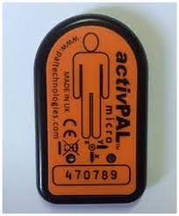
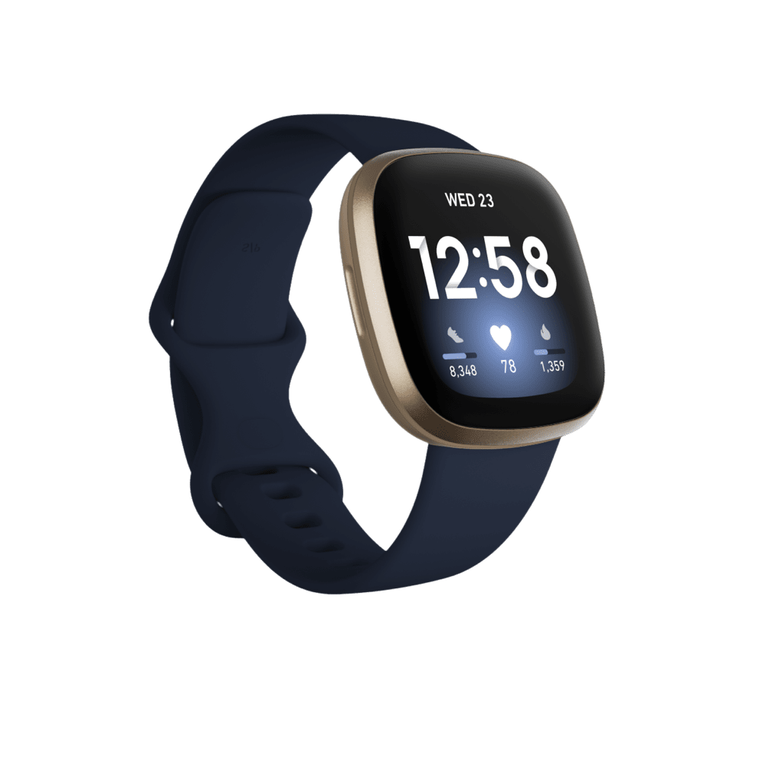
ActivPAL
Fitbit VERSA
- Following the meeting you / the young person shares the adult supporters’ email address(es) with the research team. Please check with adult supporters that they are happy for us to email them before sending us their email address.
- The adult supporters will then be sent a link to a consent form that they will need to complete.
- You may need to help the young person with the following steps:
- When each adult supporter has consented, the research team will email you / the young person the list of the consented adult supporters and the instructions to download the CONNECTPlus app on a device the young person regularly accesses. They will need to accept the terms and conditions and privacy policy, then create an account.
- They will be sent a verification code by email. They will need to enter this code into the CONNECTPlus app to verify their account. The young person will then be able to access the MoveMore app via CONNECTPlus.
- The young person can then invite the adult supporters who have consented to taking part from within the MoveMore app so that they can access the MoveMore online dashboard. These adult supporters will be able to view all information about the young person that is stored in the app via the online dashboard.
- The young person will need to download the fitbit app onto a device they regularly access, accept the terms and conditions and privacy policy and set up an account with a made-up name. The app needs to be linked the to the fitbit.

Being named as an adult supporter
Your child / the child you care for can nominate you as an adult supporter in the MoveMore app. If you are nominated, you will need to complete your own adult supporter consent form. You will then need to go through a multifactor verification process to verify your email address. Then, you will need to accept the terms of conditions and confirm that you have consented to being involved in the MoveMore study. Once this is complete, you will be able to gain access to the MoveMore online dashboard.

Young people can take part without nominating their parent / legal guardian as an adult supporter, provided a parent / legal guardian attends the meeting described above and completes the consent forms.

If you are also taking part as an adult supporter, you will need to accept the privacy policy and terms and conditions on the online dashboard only. You will be asked to read the app handbook, which is in the resources section of the online dashboard and app.

The table below explains what the YP will do in different weeks of the study.

Week number | What the young person needs to do | What they don’t do
Week 1 | - Wear the Fitbit on your wrist.  - Wear a small ActivPAL device on your right thigh, which is secured by a waterproof dressing. The dressing simply holds the device in the correct position on top of your skin. It isn’t attached to your skin in any way. This device on your thigh also measures your movements. It helps us to tell whether you are sitting, standing or lying down, which the Fitbit doesn’t do.  - Because the dressing is waterproof, the ActivPAL device can be left on throughout the first week.  - Complete the activity diary.  - Remove and return the ActivPAL (and completed activity diary if you did it on paper) to the researchers via secure delivery in a stamped addressed envelope, which will be provided.  If you completed the activity diary electronically, please email it to the research team (bchc.movemore@nhs.net ). | - Use the MoveMore app
Week 2-13 | - Use the MoveMore app with your adult supporters.  - Wear the Fitbit on your wrist everyday in that time. You can wear it at night also if you want to, but you don’t have to.  - The Fitbit can be charged overnight when needed.  - Keep a daily record of how long you spend undertaking activities directly related to the app, for example entering information onto it / having meetings / conversations to complete various parts of the app (not including physical activities you choose to do). Your adult supporters can help with this. We’ll email a form for you to do this on. Like the activity diary, you can do it electronically on the form or print it and complete it on paper.  - I will call / have a virtual meeting with you on Microsoft teams at the end of the second week to see how you are getting on. | - Wear the ActivPAL device  - Complete the activity diary
Week 13 | - Use the MoveMore app with your adult supporters.  - Wear the Fitbit on your wrist everyday.  - The Fitbit can be charged overnight when needed.  - Wear the ActivPAL device on your thigh (we’ll send it back to you).  - Keep a daily record of how long you spend undertaking activities directly related to the app.  - Complete the activity diary.  - Remove and return the ActivPAL (and the activity diary if you completed it on paper) to the researchers via secure delivery in a stamped addressed envelope, which will be provided.
After week 13 | - I will interview you and each of your adult supporters individually on Microsoft teams (virtual interview) about their experience.  - The videos of the interviews will be saved and stored securely.  - You will complete the same questionnaire about activities you do outside of school / work that you completed at the beginning.  - Do another multiple-choice quiz.  - You and your adult supporters will be able to continue using the app for 2 years after this initial 13-week testing period if you wish to. Researchers will continue to collect and analyse information collected by the app in this time. If we make any changes to the app in this time, it will be automatically updated.

What you need to do if you’re an adult supporter:

- You will need to access the MoveMore online dashboard on a device you can frequently access in the place where you see the young person. You will be able to view all the same information as the young person and you can edit some fields. You won’t be able to edit changes the young person or other adult supporters have made.
- You and other adult supporters will start supporting the young person to use the app in the second week of the study onwards.
- You may be involved in planning activities with the young person and helping to enter them onto their movement plan in the app, talking to them about their comfort, helping to enter equipment information, places they go or new adult supporters, writing goals in the app and recording when they’ve been achieved, describing how they like to move, entering journal entries (you or the young person can do this), creating or reading stories about movement experiences.
- The young person may need your support to rate how confident they are feeling about movement or their comfort level, or to tick off activities they have done from their movement plan that day.
- You will be asked to keep a daily record of how long you spend undertaking activities directly related to the app, for example entering information onto it / having meetings / conversations to complete various parts of the app (you won’t record the time spent doing physical activities the young person chooses to do).
- Some of the young person’s adult supporters will need to help them complete a diary of the activity they are doing for each 30 minutes of the day and their waking and bed times in the 1st and 13th week of the study. Not all adult supporters will do this. If you are a key contact (see below), you will be involved in this.
- I will interview you virtually on Microsoft teams about your experience in / after the 13th week. This video of this interview will be saved securely.

There is a handbook in the resources section of the online dashboard that explains how each section of the app works and includes advice for adult supporters using the app with young people. It also explains the co-design process we have been through so far. This will explain why the apps current content was included and what its purpose is.

We strongly recommend reading the handbook prior to supporting the young person with using the app.

The young person may nominate you as a key contact. They nominate one key contact in each place they go to. The key contact’s role is to have regular communication with the young person about their movement, guided by the app’s contents. You will sometimes need to find a private, quiet space to do this in. Key contacts liaise with other adults in the place you see the young person, acting as an advocate for them to facilitate reaching their goals / trying new activities / making any changes they would like to explore etc. If you are nominated as a key contact and you don’t wish to do that role, the young person will be asked to choose someone else.

Additional information:

We don’t know how often young people or adult supporters will use the app, how long they’ll use it for or how long they’ll spend doing activities linked to the app. That’s why we’re asking young people and their adult supporters to record that for us. We hope that young people will use it everyday, for things like:
- looking at their movement plan and ticking off activities they’ve done
- rating how comfortable they are or how they’re feeling about moving that day
- looking at their moving minutes for that day, or the day before to see how they’re progressing
- checking their goals.

Once the app is set up, we estimate this will take the young person 5-20 minutes a day, depending on what you’re using the app for that day. We expect that adult supporters will use it less frequently, depending on their role and how often they see the young person. A parent / guardian may look at it everyday to understand how much activity has been done, whereas a physiotherapist may only look for 10 minutes before they’re going to see the young person for an appointment.

We are videoing the interviews because being able to see the young person’s body language, facial expressions and the interactions between themselves and any adults supporting them in the interview gives us a deeper, more detailed understanding of their experiences than just hearing the words they say. Also, if they have any difficulties with communicating, being able to see each other when we’re talking with us helps both. The researchers will be able to access all the information collected in the MoveMore app / online dashboard and some of the information collected by the Fitbit the young person wears (to do with heart rate, movement and energy use).

Do we have to take part?
No. It is up to you and the young person. Their healthcare will not change whether you / they decide to take part or not.

What if we change our minds about taking part?
You can pull out at any stage, and it won’t change the care the young person receives. I will still use any information I have already collected, but this will remain anonymous. The young person will need to delete their CONNECTPlus account.

What if an adult supporter changes their mind about taking part?

If this happens, they will delete their account and we will ask the young person to ensure they are no longer on their adult supporter list on the MoveMore app. If they were a key contact, they will need to nominate a new key contact for the place where they saw them. If they were the only adult supporter, the young person will need to choose a new one and we will contact them about the study and let them know if they can be added to the adult supporters list.

When will it be and how long will it last?
The initial testing period will take place between September 2023 and March 2024. The young person will have the option to continue using the app with their adult supporters for 2 years after this initial testing period. We will continue to collect and analyse information the app collects in this time, to assess continued use of it.

What are the benefits of taking part?
- You will be helping us to make sure the app works well, so it is useful for your child / family member and other young people with disabilities.
- The young person will be able to continue using the app with their adult supporters for 2 years after the initial testing period if you / they wish to.
- The young person can keep the Fitbit, it is gifted to them.
- The young person will receive a £10 payment as a thank you for participating.
- I hope that lots of young people will use the programme in the future, helping them to live healthy lifestyles and you / your family member will have helped with this.

What are the disadvantages of taking part?
The young person participating and yourself will need to find time for the first and second appointment and the individual exit interview.

The young person will need to spend some time using the app, for example adding their adult supporters, writing goals, adding plans and lists, creating a movement plan etc. They may need your support with this. Virtual appointments may be held in school or working hours.

By accepting the terms and conditions of the Fitbit app, you are agreeing that the young person’s data will be stored on servers in the USA, where there are different data security laws to in the UK. This is why the young person’s real name will not be used for the Fitbit account, so they won’t be identifiable. They will not be able to participate if you / they do not wish to accept the terms and conditions of both apps.

Will anyone else know we are taking part?
No one other than the young person and their adult supporters (that the young person invites) will know that the young person has participated unless you want to tell them about it. Young people may be asked about why they have a new wearable device, but it’s up to them whether they wish to tell anyone.

Young people and adult supporters will use their real names in the MoveMore app, but the app is secure, so no one else can see this other than the young person and their adult supporters. There will be opportunities to upload photos / videos to the app. Young people can choose to export various screens as PDFs, such as the goal achievement certificates and can share them on social media if they wish to. They can also choose to share a story about what they’ve been doing or their achievements which can be shared with other young people using the app.

When I share the results of the study, I will use some quotes from the exit interviews, but it won’t say who said them. I will summarise the data collected anonymously. All electronic information will be encrypted and/or password protected (which means it won’t be readable by anyone who shouldn’t see it). Any information kept on paper that could identify you or the young person will be transported in the same secure way as health records and will be kept in a locked filing cabinet that is only accessed by the researchers.

I may publish the data collected, or use it in other research, but this will be anonymous.

How many others are taking part?
Between 10-20 young people will be taking part. Each young person can have up to 10 adult supporters who will also be taking part in the study.

Will it affect my family member’s normal healthcare?
The study is not related to your family member’s routine healthcare. This will not change as a result of their participation.

What happens when the study is finished?

We intend to apply for future funding to improve the app and collect more research evidence about how well it works following the initial testing period. We may make it available for purchase following this study. If funding is secured, the app will continue to be improved and updated and you will have ongoing access to it. If further funding is not secured, the app will be withdrawn after the 2-year period.

The Fitbit is gifted to the young person at the end of the initial 13-week testing period. They can continue to use it with our app or use it in any other way they wish to after this time.

On the consent form it will ask if you are happy to be contacted about future studies. You can choose to say yes or no to this. If you say yes, we may invite you / the young person to be part of future studies relating to the MoveMore app. You are still able to participate in this research if you choose to say no.

You will be able to keep up with what’s happening and the results of the study via the study website (https://bit.ly/3n3sKfN). The results will be used to write presentations and to publish in a medical magazine so I can share what we find out with other families who have children with disabilities and other professionals. I will apply for future funding to make any changes needed to the app that are identified in this testing, and to carry out further pilot testing with more young people involved.
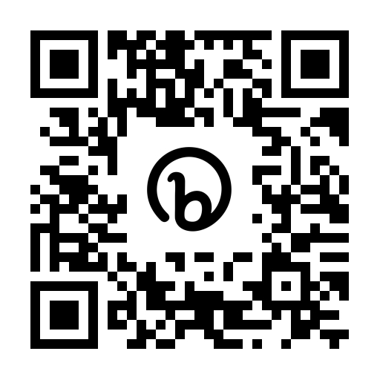
Scan the QR code above to access the study website or visit https://bit.ly/3n3sKfN
for more information.

Who is organising and funding the research?
Birmingham Community Healthcare NHS Foundation Trusts are responsible for running the study in accordance with existing research legislation and guidelines. The study is funded by the National Institute for Health and Care Research.

Who is reviewing the research?
All research in the NHS is looked at by an independent group of people, called a Research Ethics Committee, to protect your interests. This study has been reviewed and given a favourable ethical opinion by a research ethics committee.

How have patients and the public been involved in this study?

Co-design participants, members of the West Midlands Young Persons Steering Group, public and patient involvement representatives who are non-ambulant young people, local parents of young people with disabilities and adults attending a day centre for people with cerebral palsy have been involved in the research relating to the MoveMore app. Our patient and public involvement representatives have lived experience of long-term disability.

The patient and public involvement representatives have been involved in developing the participant information sheets and the protocol for this study. They have pilot tested the app prior to the study.
Will my data be kept confidential?
Birmingham Community Healthcare NHS Foundation Trust is the sponsor for this study based in the United Kingdom. In this research study we (Birmingham Community Healthcare NHS Foundation Trust) will use information from you/ the child you care for. We will only use information that we need for the research study. We will let very few people know your / their name or contact details, and only if they really need it for this study.
Everyone involved in this study will keep data safe and secure. We will also follow all privacy rules. Data will be kept for 5 years.
At the end of the study we will save some of the data in case we need to check it and for future research.
We will make sure no-one can work out who you are from the reports we write.
You can find out more about this on this page: https://bit.ly/3n3sKfN
The researchers would need to break confidentiality and share identifiable information with external agencies if they think there is a risk of harm to you or others at any point in the study, or disclosures of criminal activity are made. In this case the researchers will follow the Trust’s Safeguarding Policies and inform appropriate staff or agencies.

What if there are any problems?

If you have any safety concerns about the app, problems using it, concerns about the behaviour changes the app prompts, or safeguarding concerns please get in touch with me immediately using the contact details at the bottom of this page.

It is very unlikely, but if during the study any concerns about clinical care, criminal activities or safeguarding concerns are highlighted, the researchers must share this information with the relevant authorities.

If there is a journal entry that you don’t think should have been posted on the app, please flag it as inappropriate in the app or email bchc.movemore@nhs.net.

Participants are signposted to appropriate support services on the study website they can access if participating raises any issues they need to discuss.

What if I want to complain?
Please speak to the research team initially if you are worried about the study (Tel: 07701371838, email: bchc.movemore@nhs.net). If you wish to formally complain, you can contact the patient advice and liaison service (PALS) at Birmingham Community Healthcare NHS Foundation Trust using the details below:

Anne Pemberton (Patient Experience Manager) or Zarina Mansuri (Advise and liaison officer), Birmingham Community Healthcare NHS Trust, PALS, Moseley Hall Hospital, Alcester Road, Moseley, Birmingham, B13 8JL
Tel: 0800 917 2855 or 0121 466 6502 (Anne), 0121 466 6507 (Zarina)
e-mail: contact.bchc@nhs.net

What if I want to find out more about the study?
If you have questions about any aspect of the study that are not answered by this information sheet, please contact Marilyn Bradbury, Clinical Research Fellow, Medical Directorate, Research and Innovation, Birmingham Community Healthcare NHS Foundation Trust, Trust Headquarters, 3 Priestley Wharf, 20 Holt Street, Birmingham, B7 4BN. Tel: 07701371838. E-mail: bchc.movemore@nhs.net

Thank you for taking time to read this information.

