Young people aged 16-25 Participant Information Sheet
Version 2 15/08/2023 IRAS Project ID: 327188

Research Title: | Feasibility of the MoveMore digital intervention: reducing sedentary behaviour in non-ambulant young people with long term disabilities (MoveMore).
Chief Investigator: | Mrs Marilyn Bradbury, Clinical Research Fellow, Birmingham Community Healthcare NHS Foundation Trust

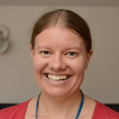
I’m Marilyn Bradbury. I would like to invite you to be involved in my research project. To help you to decide whether you would like to help us with testing the app we have designed, this information sheet explains what you would need to do. Please take time to read the information and contact me if you have any questions. It can be helpful to talk to your friends and family about the research when you are deciding whether to participate.

What is the study about?

Previous research has shown that young people with disabilities do less physical activity than able-bodied young people. It highlighted that research into how those working with disabled young people can encourage them to move more is needed.

I want to help young people who use a wheelchair and are unable to walk due to their disability, to spend less time being sedentary. Being sedentary means you’re awake but using very little energy. This includes:
- Time on your phone
- Watching TV
- Playing video games
- Reading
Spending long periods of time being sedentary reduces fitness, and can increase the risk of obesity, type 2 diabetes, heart disease and mental health issues.

In the title of this research, I have used the word “non-ambulant” to describe young people who use a wheelchair and are unable to walk due to their disability, or who only walk short distances as part of their physiotherapy programme, with support of a body support walker.

Aim of the study

The aim of this study is to test the MoveMore app, that has been co-designed to support young people who are unable to walk due to their disability to move more regularly through their day. To do this, you will use the MoveMore app and invite the adults who support you to use an online dashboard. The adult supporters you can invite to use the online dashboard include your family members, carers, health and educational professionals. You decide which adults you wish to invite. You will need to have at least one adult supporting you, as they need to approve the guides you make in the “How I move” section when the review date passes.

We have worked with young people with disabilities, family members of young people with disabilities, professionals who work with young people with disabilities, experts / academics who are interested in disability, physical activity or using technology in health care and other interested parties to design the MoveMore app together.

An early version of the app is now available. We want you and the adults who support you to help us to test it. We want to find out what improvements need to be made to the MoveMore app before we do more research to find out whether it does support young people to move more regularly.

Why do you want me to take part?

Young people who use a wheelchair most of the time and are unable to walk, or only walk short distances with the help of a body support walker and the adults who support them are being invited to test the app. The young people need to be 13 - 25 years old, have a long-term disability, live in the UK, be able to communicate using English language (including via a communication aid) in a virtual interview and have enough understanding to be able to answer the questions we will ask about using the app.

You can invite your family members, carers, health, and educational professionals to take part as your adult supporters. Any adult supporters you invite to use the app with you will need to share their email address with you and consent to taking part in the study.

What will I need to do?
You or your parent/ guardian will need to contact us using the contact details at the end of this information sheet or on the study website (https://bit.ly/3n3sKfN) to let us know you want to take part. We’ll send you a participant information sheet to read.
- You will need to attend a virtual meeting with or without an adult supporter. In this meeting you will need to show identification such as a birth certificate or passport, confirm that you meet the inclusion criteria, understand the study and confirm that you wish to take part. You will be emailed a link to an online consent form which you will need to complete (with the support of an adult if needed).
Once the consent form is completed, an initial virtual appointment will be held on Microsoft teams. It can just be you and I online, or an adult who helps you can join us if you would like them to. It’s up to you. In this appointment:

- I will collect some information about you and the activities you do.
- I will explain how to use the app and the two wearable devices I will send to you in the post. The ActivPALTM is a type of sensor called an accelerometer that collects information about your movement. It doesn’t have any effect on you and is not a medical device.
- I will explain about completing an activity diary for the first week of wearing the two wearable devices and the last week that you are testing the app.
- The diary can be completed in an electronic format (word document) or can be printed and completed on paper and be posted back to the research team with the ActivPALTM device.
- We will do a short multiple-choice quiz.
- We will decide what date you will start wearing the devices and completing the activity diary.
- You can let me know which adult supporters you are inviting to participate in the study (e.g. family members / school / educational staff / carers / healthcare professionals). Adult supporters will only be able to access the online dashboard they use once they have provided their consent to take part in the study and you have invited them via the app. They will be able to view all information about you that is stored in the app via the online dashboard.

After the meeting:
- You’ll complete a questionnaire about the activities you do outside of school / work and how you feel about doing them. This takes 45 mins – 1 hour.
- We’ll ask you to provide email addresses of your adult supporters. Please check with adult supporters that they are happy for us to email them before sending us their email address.
- Your adult supporters will then be emailed to complete consent forms too.
- When your adult supporters have given consent, the research team will send you a list of which adult supporters consented to taking part and instructions about downloading an app called CONNECTPlus.
- You will need to accept the terms and conditions and privacy policies of the CONNECTPlus app.
- You can then create an account.
- You will need to complete a multi factor verification process. You will be sent a verification code, via email, which you will need to enter into the CONNECTPlus app.
- You can then access the MoveMore app via CONNECTPlus.
- You’ll invite your adult supporters who have consented to taking part from within the MoveMore app so that they can access the MoveMore online dashboard.

I will send you two wearable devices in the post, that are shown in the pictures below.

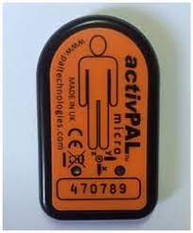
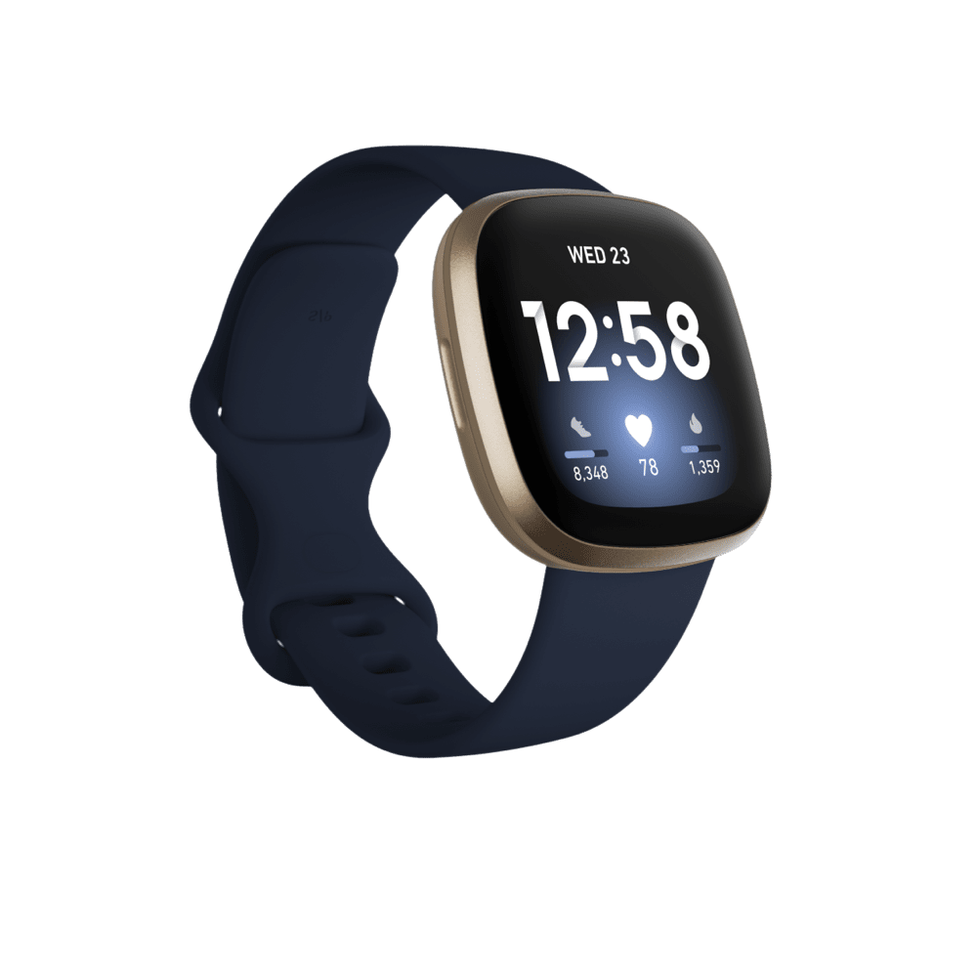
ActivPALTM
Fitbit VERSA
You will need to:

- download the Fitbit app from an app store and register for the Fitbit app using a made-up name, so no one will be able to identify you via that app and link the app to the fitbit.

Adult supporters are encouraged to read the app handbook, which is stored within the resources section of the MoveMore app and the adult supporter online dashboard. You can also read it if you want to, but you don’t have to. The table below explains what you will do in different weeks of the study.

Week number | What the young person needs to do | What they don’t do
Week 1 | - Wear the Fitbit on your wrist.  - Wear a small ActivPALTM device on your right thigh, which is secured by a waterproof dressing. The dressing simply holds the device in the correct position on top of your skin. It isn’t attached to your skin in any way. This device on your thigh also measures your movements. It helps us to tell whether you are sitting, standing, or lying down, which the Fitbit doesn’t do.  - Because the dressing is waterproof, the ActivPALTM device can be left on throughout the first week.  - Complete the activity diary.  - Remove and return the ActivPALTM (and completed activity diary if you did it on paper) to the researchers via secure delivery in a stamped addressed envelope, which will be provided. If you completed the activity diary electronically, please email it to the research team (bchc.movemore@nhs.net ). | - Use the MoveMore app
Week 2-13 | - Use the MoveMore app with your adult supporters.  - Wear the Fitbit on your wrist everyday in that time. You can wear it at night also if you want to, but you don’t have to.  - The Fitbit can be charged overnight when needed.  - Keep a daily record of how long you spend undertaking activities directly related to the app, for example entering information onto it / having meetings / conversations to complete various parts of the app (not including physical activities you choose to do). Your adult supporters can help with this. We’ll email a form for you to do this on. Like the activity diary, you can do it electronically on the form or print it and complete it on paper.  - I will call / have a virtual meeting with you on Microsoft teams at the end of the second week to see how you are getting on. | - Wear the ActivPALTM device  - Complete the activity diary
Week 13 | - Use the MoveMore app with your adult supporters.  - Wear the Fitbit on your wrist everyday.  - The Fitbit can be charged overnight when needed.  - Wear the ActivPALTM device on your thigh (we’ll send it back to you).  - Keep a daily record of how long you spend undertaking activities directly related to the app.  - Complete the activity diary.  - Remove and return the ActivPALTM (and the activity diary if you completed it on paper) to the researchers via secure delivery in a stamped addressed envelope, which will be provided.
After week 13 | - I will interview you and each of your adult supporters individually on Microsoft teams (virtual interview) about their experience.  - The video of these interviews will be saved securely.  - Do another multiple-choice quiz.  - You and your adult supporters will be able to continue using the app for 2 years after this initial 13-week testing period if you wish to. Researchers will continue to collect and analyse information collected by the app in this time. If we make any changes to the app in this time, it will be automatically updated  - You will complete the same online questionnaire about activities you do outside of school / work that you completed at the beginning.

We are videoing the interviews because being able to see your body language, facial expressions and the interactions between you and any adults supporting you in the interview gives us a deeper, more detailed understanding of your experiences than just hearing the words you say. Also, if you have any difficulties with communicating, being able to see each other when we’re talking helps us both. The researchers will be able to access all of the information collected in the MoveMore app and some of the information collected by the Fitbit (to do with heart rate, movement and energy use) in the online dashboard.

We don’t know how often young people will use the app, how long they’ll use it for or how long they’ll spend doing activities linked to the app. That’s why we’re asking young people and their adult supporters to record that for us. We hope that you’ll use it everyday, for things like:
- looking at your movement plan and ticking off activities you’ve done
- rating how comfortable you are or how you’re feeling about moving that day
- looking at your moving minutes for that day, or the day before to see how you’re progressing
- checking your goals.
Once the app is set up, we estimate this will take 5-20 minutes a day, depending on what you’re using the app for that day.

Do we have to take part?

No. It is up to you. Your healthcare will not change whether you decide to take part or not.

What if I change my mind about taking part?

You can pull out at any stage, and it won’t change the care you receive. We will still use any information we have already collected, but this will remain anonymous. You will need to delete your CONNECTPlus account.

What if an adult supporter changes their mind about taking part?

If this happens, they will delete their account and we will ask you to ensure they are no longer on your adult supporter list on the MoveMore app. If they were a key contact, you will need to nominate a new key contact for the place where you saw them. If they were your only adult supporter, you will need to choose a new one and we will contact them about the study and let you know if they can be added to your adult supporters list.

When will it be and how long will it last?

The initial testing period will take place between September 2023 and March 2024. You and your adult supporters will have the option to continue using the app for 2 years after this initial testing period. We will continue to collect and analyse information the app collects in this time, to assess continued use of it.

What are the benefits of taking part?

- You will be helping us to make sure the app works well, so it is useful for you and other young people with disabilities.
- You and your adult supporters will be able to continue using the app for 2 years after the initial testing period if you / they wish to.
- You can keep the Fitbit, it is gifted to you.
- We will send you and your adult supporters a £10 payment to thank you for taking part.
- I hope that lots of young people will use the programme in the future, helping them to live healthy lifestyles and you will have helped with this.

What are the disadvantages of taking part?

You and your adult supporters need to find time for the first and second appointment and individual exit interviews. You will need to spend some time using the app, for example adding your adult supporters, writing goals, adding plans and lists, creating a movement plan etc. Virtual appointments may be held in school or working hours.

By accepting the terms and conditions of the Fitbit app, you are agreeing that your data will be stored on servers in the USA, where there are different data security laws to in the UK. This is why your real name will not be used for the Fitbit account, so you won’t be identifiable. You will not be able to participate if you do not wish to accept the terms and conditions of both apps.

Will anyone else know we are taking part?

No one other than your adult supporters (that you invite from the app) will know you have participated unless you want to tell them about it. You may be asked about why you have a new wearable device, but it’s up to you whether you wish to tell anyone.

You and your adult supporters will use their real names in the MoveMore app, but the app is secure, so no one else can see this other than you and your adult supporters. There will be opportunities to upload photos / videos to the app. You can choose to export various screens as PDFs that you can share on social media if you wish to, for example your goal certificates. You can also choose to share a story about what you’ve been doing or your achievements which can be shared with other young people using the app.

When I share the results of the study, we will use some quotes from the exit interviews, but it won’t say who said them. I will summarise the data collected anonymously. All electronic information will be encrypted and/or password protected (which means it won’t be readable by anyone who shouldn’t see it). Any information kept on paper that identifies you will be transported in the same secure way as health records and will be kept in a locked filing cabinet that is only accessed by the researchers.

We may publish our data, or use it in other research, but this will be anonymous.

How many others are taking part?

Between 10-20 young people will be taking part in testing the MoveMore app. Each young person can have up to 10 adult supporters who will also be taking part in the study.

Will it affect my normal healthcare?

The study is not related to your routine healthcare. This will not change as a result of your participation.

What happens when the study is finished?

We intend to apply for future funding to improve the app and collect more research evidence about how well it works following the initial testing period. We may make it available for purchase following this study. If funding is secured, the app will continue to be improved and updated and you will have ongoing access to it. If further funding is not secured, the app will be withdrawn after the 2-year period.

The Fitbit will be gifted to the you at the end of the initial 13-week period. You can continue to use it with our app or use it in any other way you wish to after this time.

On the consent form it will ask if you are happy to be contacted about future studies. You can choose to say yes or no to this. If you say yes, we may invite you to be part of future studies relating to the MoveMore app. You are still able to participate in this research if you choose to say no.

You will be able to keep up with what’s happening and the results of the study via the study website (https://bit.ly/3n3sKfN). The results will be used to write presentations and to publish in a medical magazine so I can share what I find out with other families who have children with disabilities and other professionals. I will apply for future funding to make any changes needed to the app that are identified in this testing, and to carry out further pilot testing with more young people involved.
Scan the QR code above to access the study website or visit https://bit.ly/3n3sKfN
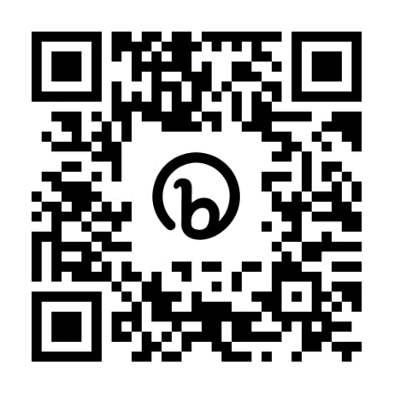
Who is organising and funding the research?

Birmingham Community Healthcare NHS Foundation Trusts are responsible for running the study in accordance with existing research legislation and guidelines. The study is funded by the National Institute for Health and Care Research.

Who is reviewing the research?

All research in the NHS is looked at by an independent group of people, called a Research Ethics Committee, to protect your interests. This study has been reviewed and given a favourable ethical opinion by a research ethics committee.

How have patients and the public been involved in this study?

Co-design participants, members of the West Midlands Young Persons Steering Group, public and patient involvement representatives who are non-ambulant young people, local parents of young people with disabilities and adults attending a day centre for people with cerebral palsy have been involved in developing the research relating to the MoveMore app. Our patient and public involvement representatives have lived experience of long-term disability.

The patient and public involvement representatives have been involved in developing the participant information sheets and the protocol for this study. They have pilot tested the app prior to the study.
Will my data be kept confidential?

Birmingham Community Healthcare NHS Foundation Trust is the sponsor for this study based in the United Kingdom. In this research study we (Birmingham Community Healthcare NHS Foundation Trust) will use information from you. We will only use information that we need for the research study. We will let very few people know your name or contact details, and only if they really need it for this study.
Everyone involved in this study will keep your data safe and secure. We will also follow all privacy rules. Data will be kept for 5 years.
At the end of the study we will save some of the data in case we need to check it and for future research.
We will make sure no-one can work out who you are from the reports we write.
You can find out more about this on this page: https://bit.ly/3n3sKfN
The researchers would need to break confidentiality and share identifiable information with external agencies if they think there is a risk of harm to you or others at any point in the study, or disclosures of criminal activity are made. In this case the researchers will follow the Trust’s Safeguarding Policies and inform appropriate staff or agencies.

What if there are any problems?

If you have any safety concerns about the app, problems using it, concerns about the behaviour changes the app prompts, or safeguarding concerns please get in touch with me immediately using the contact details at the bottom of this page.

It is very unlikely, but if during the study any concerns about clinical care, criminal activities or safeguarding concerns are highlighted, the researchers have to share this information with the relevant authorities.

If there is a journal entry that you don’t think should have been posted on the app, please flag it as inappropriate in the app or email bchc.movemore@nhs.net.

Participants are signposted to appropriate support services on the study website they can access if participating raises any issues they need to discuss.

What if I want to complain?

Please speak to the research team initially if you are worried about the study (tel: 07701371838, email: bchc.movemore@nhs.net). If you wish to formally complain, you can contact the patient advice and liaison service (PALS) at Birmingham Community Healthcare NHS Foundation Trust using the details below:

Anne Pemberton (Patient Experience Manager) or Zarina Mansuri (Advise and liaison officer), Birmingham Community Healthcare NHS Trust, PALS
Moseley Hall Hospital, Alcester Road, Moseley, Birmingham, B13 8JL
Tel: 0800 917 2855 or 0121 466 6502 (Anne), 0121 466 6507 (Zarina)
e-mail: contact.bchc@nhs.net

What if I want to find out more about the study?

If you have questions about any aspect of the study that are not answered by this information sheet, please contact Marilyn Bradbury, Clinical Research Fellow, Medical Directorate, Research and Innovation, Birmingham Community Healthcare NHS Foundation Trust, Trust Headquarters, 3 Priestley Wharf, 20 Holt Street, Birmingham, B7 4BN. Tel: 07701371838. E-mail: bchc.movemore@nhs.net

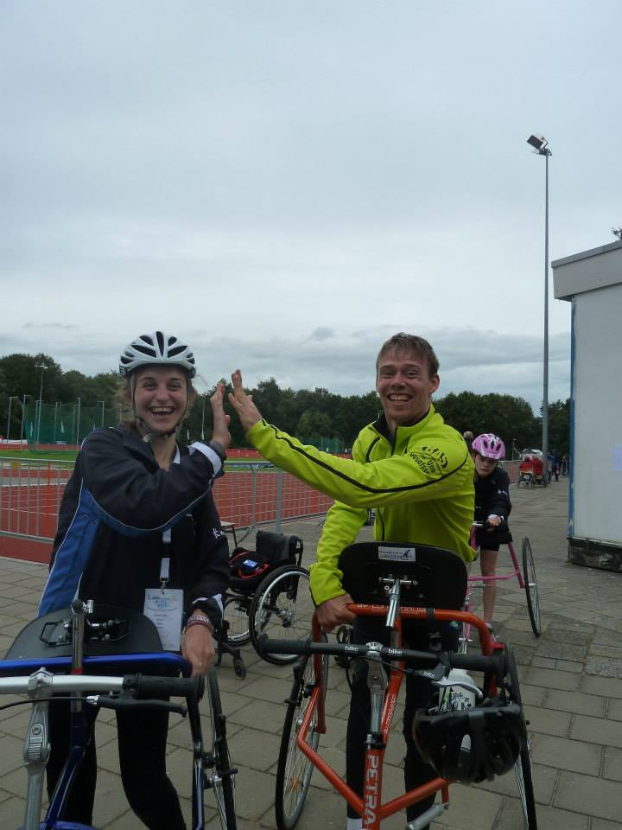
Paralympian Hannah Dines supports the MoveMore study.
Marilyn and Hannah would like to thank you for taking time to read this leaflet, and for your help.

