Participant Information Sheet – Adult supporters (including parents / guardians who are participating as an adult supporter)
Version 2 15/08/2023 IRAS Project ID: 327188
Research Title: | Feasibility of the MoveMore digital intervention: reducing sedentary behaviour in non-ambulant young people with long term disabilities (MoveMore).
Chief Investigator: | Mrs Marilyn Bradbury, Clinical Research Fellow, Birmingham Community Healthcare NHS Foundation Trust
I’m Marilyn Bradbury. I would like to invite you to be involved in my research project. To help you to decide whether you would like to help us with testing the MoveMore app, this information sheet explains what you would need to do. Please take time to read the information and contact me if you have any questions.

What is the study about?
Previous research has shown that young people with disabilities do less physical activity than able-bodied young people. Supporting them to move more has been identified as a high priority for research.

I want to help young people who use a wheelchair and are unable to walk due to their disability, to spend less time being sedentary. Being sedentary means you’re awake but using very little energy. This includes:
- Time on your phone
- Watching TV
- Playing video games
- Reading
Spending long periods of time being sedentary reduces fitness, and can increase the risk of obesity, type 2 diabetes, heart disease and mental health issues.

In the title of this research, I have used the word “non-ambulant” to describe young people who use a wheelchair and are unable to walk due to their disability, or who only walk short distances as part of their physiotherapy programme, with support of a body support walker.

Aim of the study
The aim of this study is to test the MoveMore app, that has been co-designed to support young people who are unable to walk due to their disability to be active more regularly through their day. To do this, the young person will use the MoveMore app, and the adults who support them will use an online dashboard. The adult supporters who can be invited by the young person include their parents, family members and carers. The young person decides which adult supporters they’d like to invite to the online dashboard.

I have been working with young people with disabilities, family members of young people with disabilities, professionals who work with young people with disabilities, experts / academics who are interested in disability, physical activity or using technology in health care and other interested parties to design the intervention together.

An early version of the app is now available. I want young people and the adults who support them to help us to test it. I want to find out what improvements need to be made to it before I do more research to find out whether it does support young people to move more regularly.

Why do you want me to take part?
Young people who use a wheelchair most of the time and are unable to walk, or only walk short distances with the help of a body support walker and the adults who support them are being invited to test the app. The young people need to be 13 - 25 years old, have a long-term disability, live in the UK, be able to communicate using English language (including via a communication aid) in a virtual interview and have enough understanding to be able to answer the questions we will ask about using the app.

Family members and carers (aged 16 and above) of young people who are unable to walk due to a long-term disability can take part as adult supporters. Any adult supporters who wish to be involved in this feasibility study will need to consent to taking part in the study.

What will I need to do?

The young person who you will be supporting will need to nominate you as an adult supporter and you will need to share your email address with them. This is so we can get in touch with you and they can add you as an adult supporter in the MoveMore app. If you would prefer them not to use your email for other purposes, please let them know when you share it.
Entering the study

- You will be emailed a link to an online consent form and this participant information sheet by the research team.
- Please read the information sheet and if you’d like to take part, complete the online consent form and the questions about you and your relationship to the young person and their physical activities that follow the consent form.
- You will need to have access to appropriate equipment to safely carry out moving and handling tasks, have been trained how to carry out moving and handling safely and be confident in doing so.
- Once the adult supporter list is finalised and participating adult supporters have consented, the young person, will invite you to access the MoveMore online dashboard from the MoveMore app.
- You will need to accept the terms and conditions and privacy policy and complete a multifactor verification process to verify your email address in order to create an account.
- You will need to confirm that you have consented to be part of the MoveMore study.
- You will then be able to access the MoveMore online dashboard. You will only be able to access information about young people who have invited you via the MoveMore app.

What you need to do during the study:

- You will need to access the MoveMore online dashboard on a device you can frequently access in the place where you see the young person. You will be able to view all the same information as the young person and you can edit some fields. You won’t be able to edit changes the young person or other adult supporters have made.
- You and other adult supporters will start supporting the young person to use the app in the second week of the study onwards.
- You may be involved in planning activities with the young person and helping to enter them onto their movement plan in the app, talking to them about their comfort, helping to enter equipment information, places they go or new adult supporters, writing goals in the app and recording when they’ve been achieved, describing how they like to move, entering journal entries (you or the young person can do this), creating or reading stories about movement experiences.
- The young person may need your support to rate how confident they are feeling about movement or their comfort level, or to tick off activities they have done from their movement plan that day.
- You will be asked to keep a daily record of how long you spend undertaking activities directly related to the app, for example entering information onto it / having meetings / conversations to complete various parts of the app (you won’t record the time spent doing physical activities the young person chooses to do).
- Some of the young person’s adult supporters will need to help them complete a diary of the activity they are doing for each 30 minutes of the day and their waking and bed times in the 1st and 13th week of the study. Not all adult supporters will do this. If you are a key contact (see below), you will be involved in this.
- I will interview you virtually on Microsoft teams about your experience in / after the 13th week. This video of this interview will be saved securely.

There is a handbook in the resources section of the online dashboard that explains how each section of the app works and includes advice for adult supporters using the app with young people. It also explains the co-design process we have been through so far. This will explain why the apps current content was included and what its purpose is.

We strongly recommend reading the handbook prior to supporting the young person with using the app.

The young person may nominate you as a key contact. They nominate one key contact in each place they go to. The key contact’s role is to have regular communication with the young person about their movement, guided by the app’s contents. You will sometimes need to find a private, quiet space to do this in. Key contacts liaise with other adults in the place you see the young person, acting as an advocate for them to facilitate reaching their goals / trying new activities / making any changes they would like to explore etc. If you are nominated as a key contact and you don’t wish to do that role, the young person will be asked to choose someone else.

We don’t know how often young people or adult supporters will use the app, how long they’ll use it for or how long they’ll spend doing activities linked to the app. That’s why we’re asking young people and their adult supporters to record that for us. We hope that young people will use it everyday, for things like:
- looking at their movement plan and ticking off activities they’ve done
- rating how comfortable they are or how they’re feeling about moving that day
- looking at their moving minutes for that day, or the day before to see how they’re progressing
- checking their goals.
Once the app is set up, we estimate this will take the young person 5-20 minutes a day, depending on what you’re using the app for that day. We expect that adult supporters will use it less frequently, depending on their role and how often they see the young person. A parent / guardian may look at it everyday to understand how much activity has been done, whereas a physiotherapist may only look for 10 minutes before they’re going to see the young person for an appointment.

We are videoing the interviews because being able to see your body language and facial expressions in the interview gives us a deeper, more detailed understanding of your experiences than just hearing the words you say. The researchers will be able to access all the information collected in the MoveMore app / online dashboard and some of the information collected by the Fitbit the young person wears (to do with heart rate, movement and energy use).

The young person you support, and their parent / guardian / family member will have two virtual appointments with me. The first is to check they understand the study before they consent, and that they meet the inclusion criteria. The second is to explain how to use the app and the two wearable devices I will send to them in the post. Pictures of these devices are shown below. The Fitbit provided must only be used by the young person, with the MoveMore app. It cannot be used by other people.
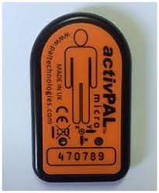
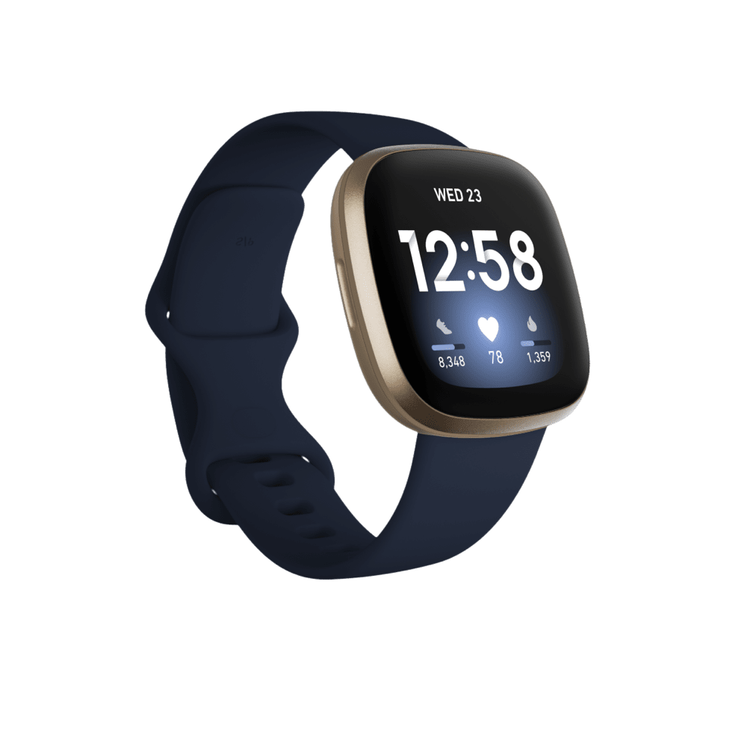
ActivPAL
Fitbit VERSA
In the meeting:
- I will explain about completing an activity diary for the first week of wearing the two wearable devices and the last week that they are testing the MoveMore app.
- The diary can be completed in an electronic format (word document) or can be printed and completed on paper and be posted back to the research team with the ActivPAL device.
- They may need your support with completing this.
- We will decide what date they will start wearing the devices and completing the activity diary.

What the young person does

The table below explains what the young person will do in different weeks of the study.

Week number | What the young person needs to do | What they don’t do
Week 1 | - Wear the Fitbit on your wrist.  - Wear a small ActivPAL device on your right thigh, which is secured by a waterproof dressing. The dressing simply holds the device in the correct position on top of your skin. It isn’t attached to your skin in any way. This device on your thigh also measures your movements. It helps us to tell whether you are sitting, standing, or lying down, which the Fitbit doesn’t do.  - Because the dressing is waterproof, the ActivPAL device can be left on throughout the first week.  - Complete the activity diary.  - Remove and return the ActivPAL (and completed activity diary id you did it on paper) to the researchers via secure delivery in a stamped addressed envelope, which will be provided. If you completed the activity diary electronically, please email it to the research team (bchc.movemore@nhs.net ). | - Use the MoveMore app
Week 2-13 | - Use the MoveMore app with your adult supporters.  - Wear the Fitbit on your wrist everyday in that time. You can wear it at night also if you want to, but you don’t have to.  - The Fitbit can be charged overnight when needed.  - Keep a daily record of how long you spend undertaking activities directly related to the app, for example entering information onto it / having meetings / conversations to complete various parts of the app (not including physical activities you choose to do). Your adult supporters can help with this. We’ll email a form for you to do this on. Like the activity diary, you can do it electronically on the form or print it and complete it on paper.  - I will call / have a virtual meeting with you on Microsoft teams at the end of the second week to see how you are getting on. | - Wear the ActivPAL device  - Complete the activity diary
Week 13 | - Use the MoveMore app with your adult supporters.  - Wear the Fitbit on your wrist everyday.  - The Fitbit can be charged overnight when needed.  - Wear the ActivPAL device on your thigh (we’ll send it back to you).  - Keep a daily record of how long you spend undertaking activities directly related to the app.  - Complete the activity diary.  - Remove and return the ActivPAL (and the activity diary if you completed it on paper) to the researchers via secure delivery in a stamped addressed envelope, which will be provided.
After week 13 | - I will interview you and each of your adult supporters individually on Microsoft teams (virtual interview) about their experience.  - The video of these interviews will be saved securely.  - You will also complete the same questionnaire about activities you do outside of school / work that you completed at the beginning.  - Do another multiple-choice quiz.  - You and your adult supporters will be able to continue using the app for 2 years after this initial 13-week testing period if you wish to. Researchers will continue to collect and analyse information collected by the app in this time. If we make any changes to the app in this time, it will be automatically updated.

Do I have to take part?
No, It is up to you. Your role will not be influenced whether you decide to take part or not.

What if I change my mind about taking part?
You can pull out at any stage. I will still use any information that has already been collected, but this will remain anonymous. Please delete your CONNECTPlus account and let us know you wish to leave the study using the contact details at the end of this information sheet.

When will it be and how long will it last?
The initial testing period will take place between September 2023 and March 2024. You and the young person will have the option to continue using the app for 2 years after this initial testing period. We will continue to collect and analyse information the app collects in this time, to assess continued use of it.

What are the benefits of taking part?
- You will be helping us to make sure the app works well, so it is useful for the young person you support and other young people with disabilities.
- You and the young person you support will be able to continue using the app for 2 years after the initial testing period if you / they wish to.
- The young person can keep the Fitbit, it is gifted to them.
- You will receive a £10 payment to thank you for your time.
- I hope that lots of young people will use the programme in the future, helping them to live healthy lifestyles and you will have helped with this.

What are the disadvantages of taking part?
You will need to spend some time reading the handbook and using the app, for example supporting the young person to write goals, add plans and lists, create a movement plan etc. There are ongoing things to do in the app such as ticking off activities that need to be done and rating comfort level / how the young person feels about moving. You need to find time for the individual exit interviews.

Will anyone else know I am taking part?
No one other than the young person and their other adult supporters (that they invite from the app) will know you have participated unless you want to tell them about it.

You will use your real name in the MoveMore app, but the app is secure, so no one else can see this other than the young person and the other adult supporters. There will be opportunities to upload photos / videos to the app. Young people can choose to export various screens as a PDF, for example their goal achievement certificates, that they can share on social media if they wish to. If you are in photographs they share with others outside the app you may become identifiable. The young person can share a story about what they’ve been doing or their achievements which can be shared with other young people using the app. If you do not wish to identifiable to people other than the young person and the other adult supporters in relation to the app or the study, please let the young person, their adult supporters and the researchers know that no photos of you should be uploaded to the app.

When I share the results of the study, we will use some quotes from the exit interviews, but it won’t say who said them. I will summarise the data collected anonymously. All electronic information will be encrypted and/or password protected (which means it won’t be readable by anyone who shouldn’t see it). Any information kept on paper that identifies you will be transported in the same secure way as health records and will be kept in a locked filing cabinet that is only accessed by the researchers.

We may publish our data, or use it in other research, but this will be anonymous.

How many others are taking part?
10-20 young people will be taking part in testing the app. Each young person can have up to 10 adult supporters who will also be taking part in the study.

Will it affect my normal healthcare?
The study is not related to your routine healthcare. This will not change as a result of your participation.

What happens when the study is finished?
We intend to apply for future funding to improve the app and collect more research evidence about how well it works following the initial testing period. We may make it available for purchase following this study. If funding is secured, the app will continue to be improved and updated and you will have ongoing access to it. If further funding is not secured, the app will be withdrawn after the 2-year period.

The Fitbit is gifted to the young person at the end of the initial 13-week testing period. They can continue to use it with our app or use it in any other way they wish to after this time.

On the consent form it will ask if you are happy to be contacted about future studies. You can choose to say yes or no to this. If you say yes, we may invite you to be part of future studies relating to the MoveMore app. You are still able to participate in this research if you choose to say no.

You will be able to keep up with what’s happening and the results of the study via the study website (https://bit.ly/3n3sKfN) The results will be used to write presentations and to publish in a medical magazine so I can share what I find out with other families who have children with disabilities and other professionals. I will apply for future funding to make any changes needed to the app that are identified in this testing, and to carry out further pilot testing with more young people involved.

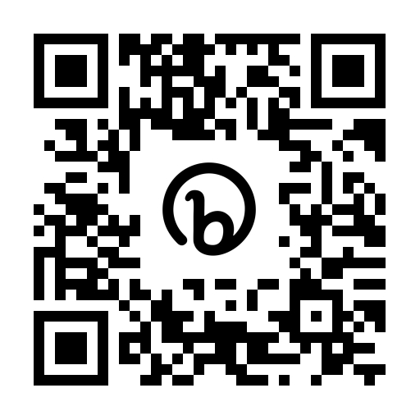
Scan the QR code above to access the study website or visit https://bit.ly/3n3sKfN
for further information.

Who is organising and funding the research?
Birmingham Community Healthcare NHS Foundation Trusts are responsible for running the study in accordance with existing research legislation and guidelines. The study is funded by the National Institute for Health and Care Research.

Who is reviewing the research?
All research in the NHS is looked at by an independent group of people, called a Research Ethics Committee, to protect your interests. This study has been reviewed and given a favourable ethical opinion by a research ethics committee.

How have patients and the public been involved in this study?
Co-design participants, members of the West Midlands Young Persons Steering Group, public and patient involvement representatives who are non-ambulant young people, local parents of young people with disabilities and adults attending a day centre for people with cerebral palsy have been involved in the research relating to the MoveMore app. Our patient and public involvement representatives have lived experience of long-term disability.

The patient and public involvement representatives have been involved in developing the participant information sheets and the protocol for this study. They have pilot tested the app prior to the study.

Will my data be kept confidential?

Birmingham Community Healthcare NHS Foundation Trust is the sponsor for this study based in the United Kingdom. In this research study we (Birmingham Community Healthcare NHS Foundation Trust) will use information from you. We will only use information that we need for the research study. We will let very few people know your name or contact details, and only if they really need it for this study.
Everyone involved in this study will keep your data safe and secure. We will also follow all privacy rules. Data will be kept for 5 years.
At the end of the study we will save some of the data in case we need to check it and for future research.
We will make sure no-one can work out who you are from the reports we write.
You can find out more about this on this page: https://bit.ly/3n3sKfN
The researchers would need to break confidentiality and share identifiable information with external agencies if they think there is a risk of harm to you or others at any point in the study, or disclosures of criminal activity are made. In this case, the researchers will follow the Trust’s Safeguarding Policies and inform appropriate staff or agencies.

What if there are any problems?

If you have any safety concerns about the app, problems using it, concerns about the behaviour changes the app prompts, or safeguarding concerns please get in touch with me immediately using the contact details at the bottom of this page.

It is very unlikely, but if during the study any concerns about clinical care, criminal activities or safeguarding concerns are highlighted, the researchers must share this information with the relevant authorities.

If there is a journal entry that you don’t think should have been posted on the app, please flag it as inappropriate in the app or email bchc.movemore@nhs.net.

Participants are signposted to appropriate support services on the study website they can access if participating raises any issues they need to discuss.

What if I want to complain?
Please speak to the research team initially if you are worried about the study (Tel: 07701371838, email: bchc.movemore@nhs.net) If you wish to formally complain, you can contact the patient advice and liaison service (PALS) at Birmingham Community Healthcare NHS Foundation Trust using the details below:

Anne Pemberton (Patient Experience Manager) or Zarina Mansuri (Advise and liaison officer), Birmingham Community Healthcare NHS Trust PALS
Moseley Hall Hospital, Alcester Road, Moseley, Birmingham, B13 8JL
Tel: 0800 917 2855 or 0121 466 6502 (Anne), 0121 466 6507 (Zarina)
e-mail: contact.bchc@nhs.net

What if I want to find out more about the study?
If you have questions about any aspect of the study that are not answered by this information sheet, please contact Marilyn Bradbury, Clinical Doctoral Research Fellow, Medical Directorate, Research and Innovation, Birmingham Community Healthcare NHS Foundation Trust, Trust Headquarters, 3 Priestley Wharf, 20 Holt Street, Birmingham, B7 4BN. Tel: 07701371838. E-mail: bchc.movemore@nhs.net

Thank you for taking time to read this information.

